**TASK 8**

**using my sql design a database whose name in imdb . create proper my sql tables ,primary key,foreign key,add data into the mysql tablesand do the following as given below ;**

1 ) movie should have multiple media (video or image)

2 ) movie can belongs to multiple genre

3 ) movie can have multiple reviews and review can belongs to a user

4) Artist can have multiple skills

5) Artist can perform multiple role in a single film

CREATE TABLE Movies (

movie_id INT AUTO_INCREMENT PRIMARY KEY,

title VARCHAR(255) NOT NULL,

release_year INT,

description TEXT

);

INSERT INTO Movies (title, release_year, description)

VALUES ('Inception', 2010, 'A mind-bending thriller by Christopher Nolan.');

SELECT * FROM Movies;

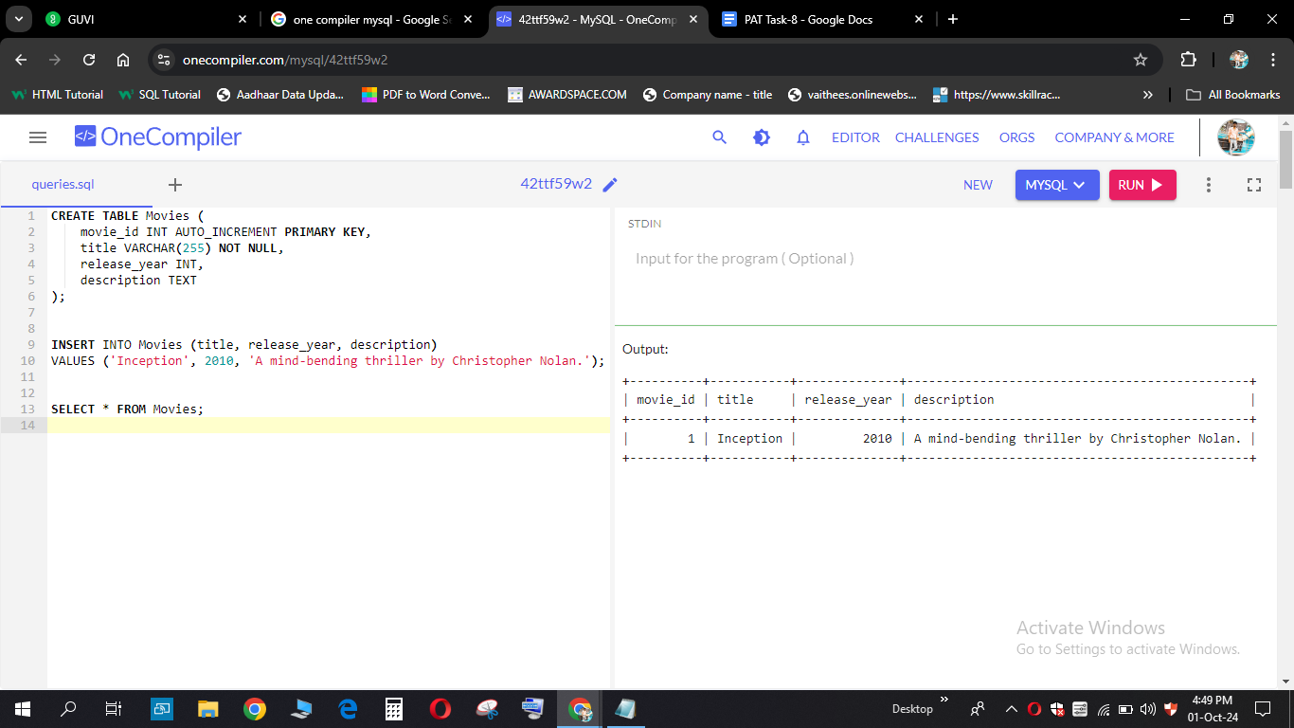

CREATE TABLE Media (

media_id INT AUTO_INCREMENT PRIMARY KEY,

movie_id INT,

media_type ENUM('image', 'video') NOT NULL,

media_url VARCHAR(255) NOT NULL,

FOREIGN KEY (movie_id) REFERENCES Movies(movie_id) ON DELETE CASCADE

);

INSERT INTO Media (movie_id, media_type, media_url)

VALUES (1, 'image', 'https://example.com/inception-image.jpg');

SELECT * FROM Media;

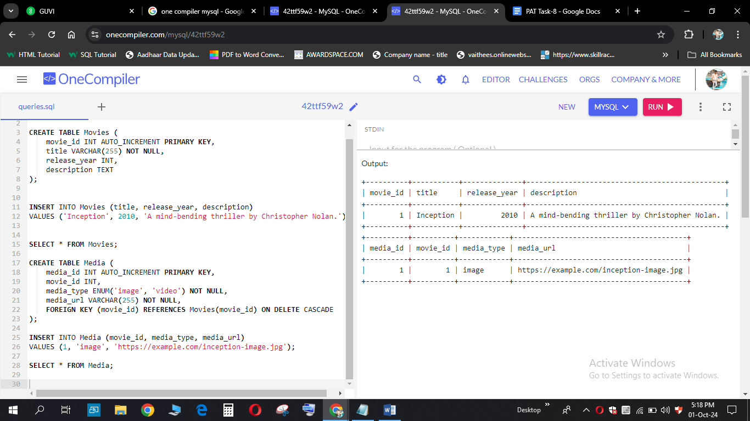

CREATE TABLE Genres (

genre_id INT AUTO_INCREMENT PRIMARY KEY,

genre_name VARCHAR(50) NOT NULL

);

INSERT INTO Genres (genre_name)

VALUES ('Sci-Fi'), ('Thriller');

SELECT * FROM Genres;

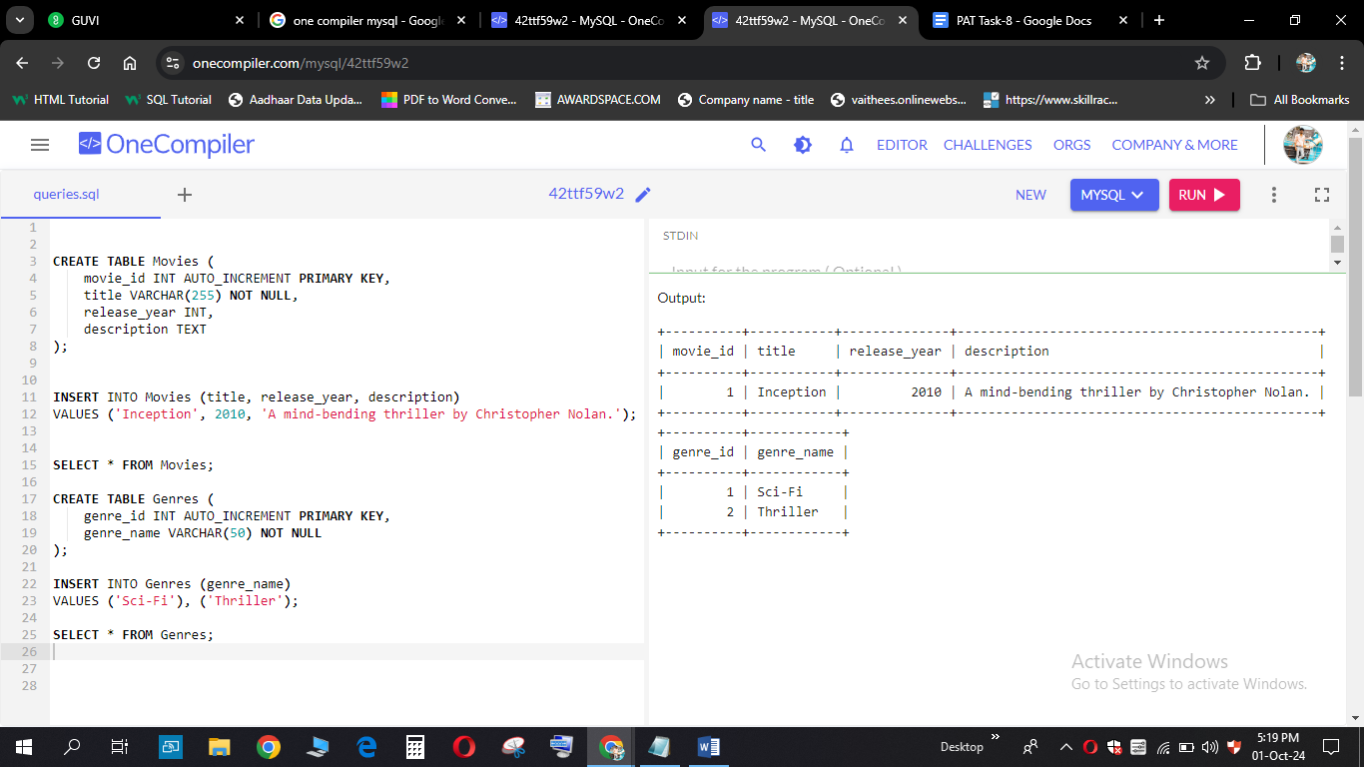

CREATE TABLE MovieGenres (

movie_id INT,

genre_id INT,

PRIMARY KEY (movie_id, genre_id),

FOREIGN KEY (movie_id) REFERENCES Movies(movie_id) ON DELETE CASCADE,

FOREIGN KEY (genre_id) REFERENCES Genres(genre_id) ON DELETE CASCADE

);

INSERT INTO MovieGenres (movie_id, genre_id)

VALUES (1, 1), (1, 2);

SELECT * FROM MovieGenres;

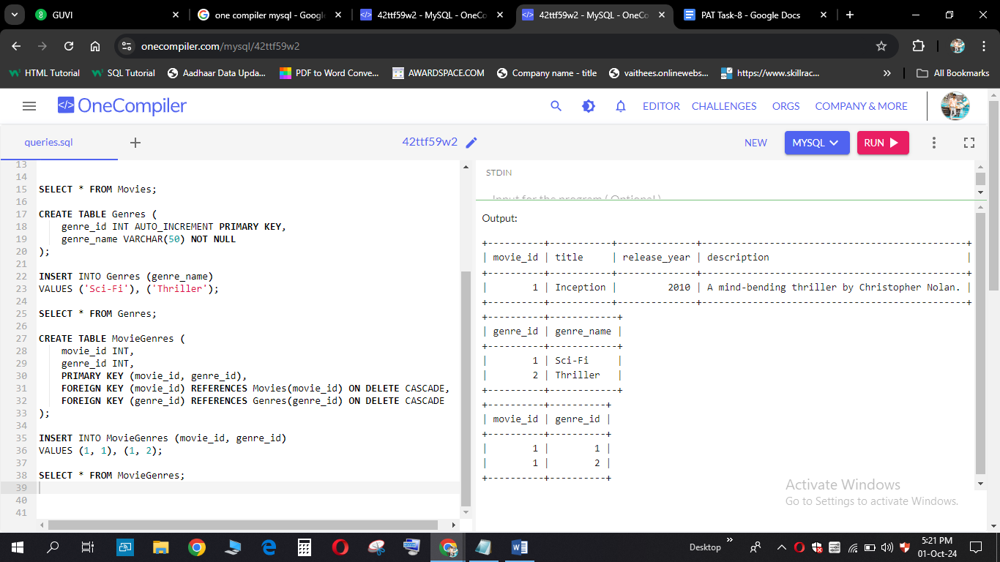

CREATE TABLE Users (

user_id INT AUTO_INCREMENT PRIMARY KEY,

username VARCHAR(255) NOT NULL,

email VARCHAR(255) NOT NULL UNIQUE

);

INSERT INTO Users (username, email)

VALUES ('john_doe', 'john@example.com');

SELECT * FROM Users;

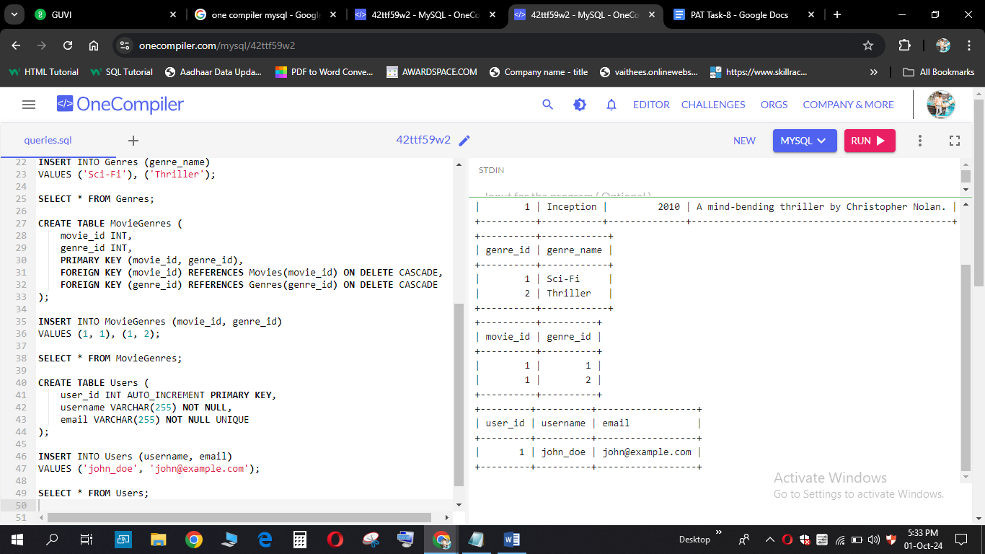

CREATE TABLE Reviews (

review_id INT AUTO_INCREMENT PRIMARY KEY,

movie_id INT,

user_id INT,

rating INT CHECK (rating >= 1 AND rating <= 10),

review_text TEXT,

FOREIGN KEY (movie_id) REFERENCES Movies(movie_id) ON DELETE CASCADE,

FOREIGN KEY (user_id) REFERENCES Users(user_id) ON DELETE CASCADE

);

INSERT INTO Reviews (movie_id, user_id, rating, review_text)

VALUES (1, 1, 9, 'Amazing movie with a great concept.');

SELECT * FROM Reviews;

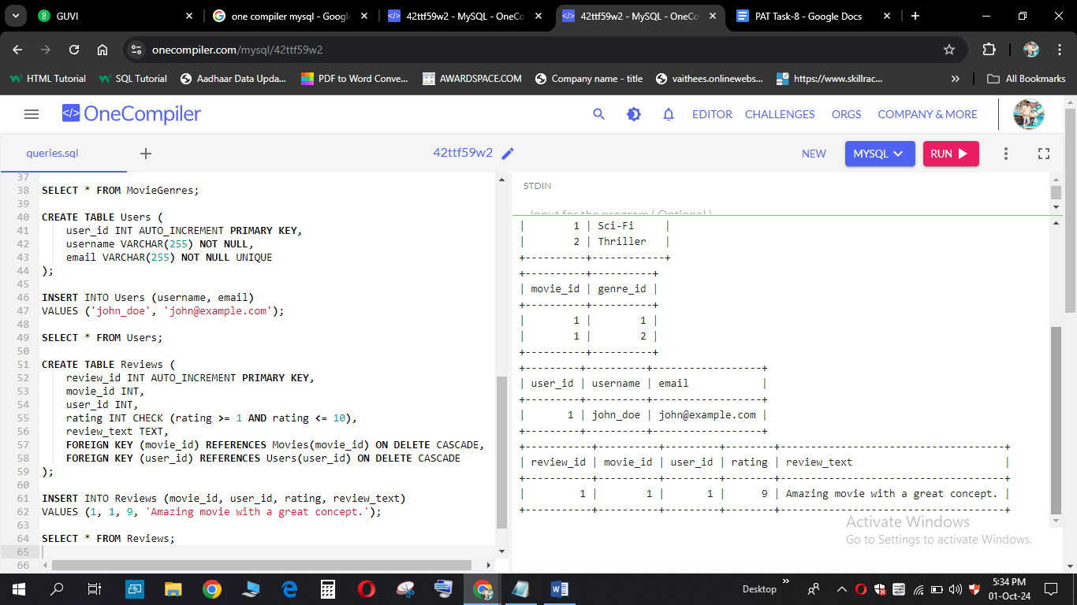

CREATE TABLE Artists (

artist_id INT AUTO_INCREMENT PRIMARY KEY,

name VARCHAR(255) NOT NULL,

birth_date DATE

);

INSERT INTO Artists (name, birth_date)

VALUES ('Leonardo DiCaprio', '1974-11-11');

SELECT * FROM Artists;

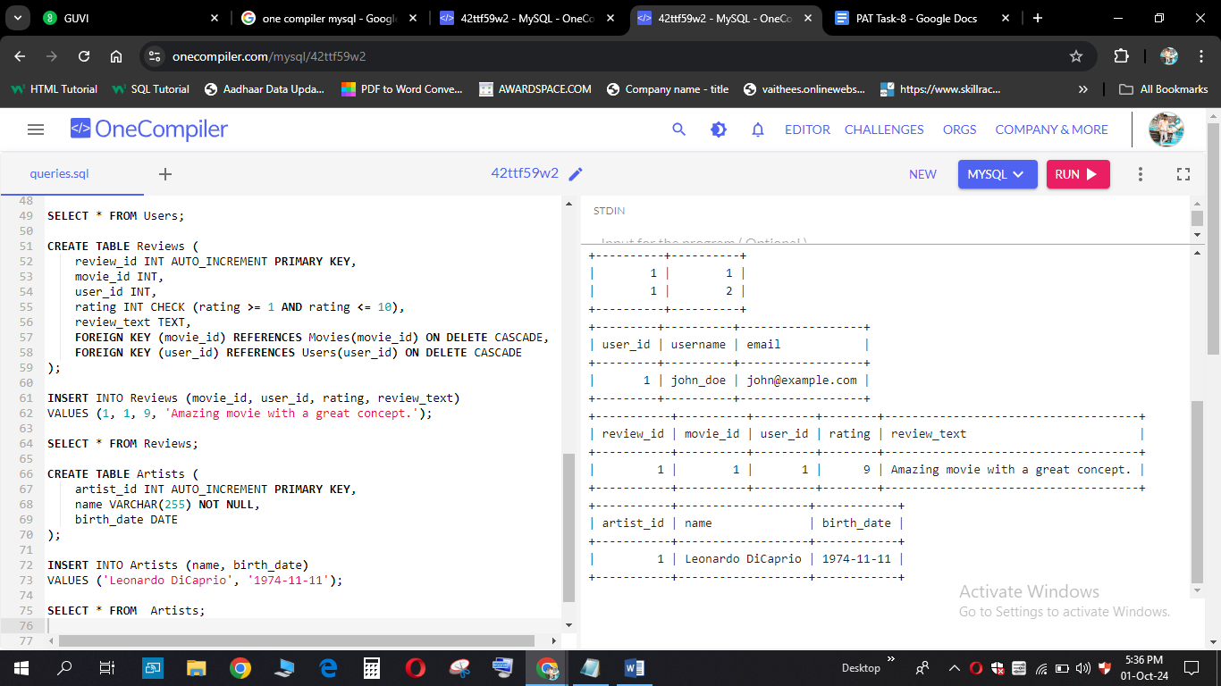

CREATE TABLE Skills (

skill_id INT AUTO_INCREMENT PRIMARY KEY,

skill_name VARCHAR(50) NOT NULL

);

INSERT INTO Skills (skill_name)

VALUES ('Acting'), ('Directing');

SELECT * FROM Skills;

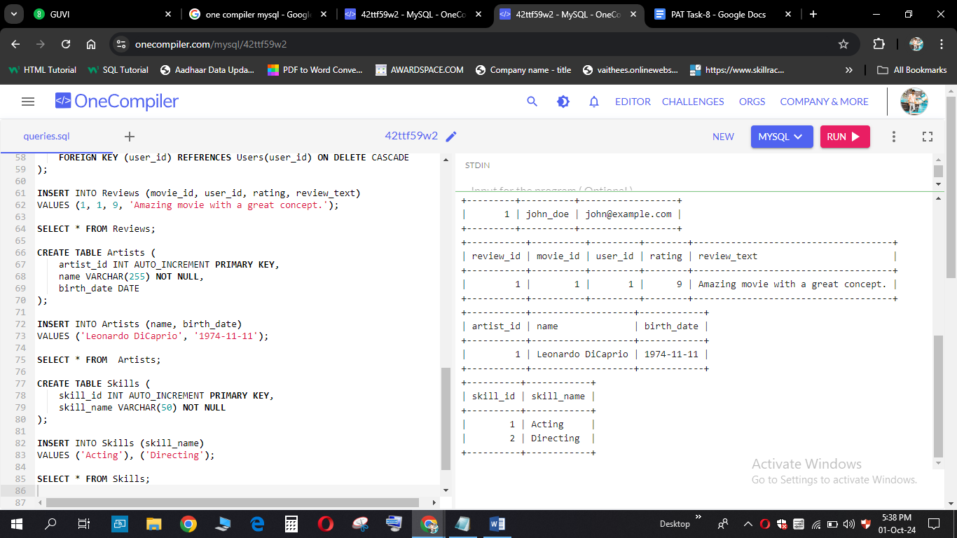

CREATE TABLE ArtistSkills (

artist_id INT,

skill_id INT,

PRIMARY KEY (artist_id, skill_id),

FOREIGN KEY (artist_id) REFERENCES Artists(artist_id) ON DELETE CASCADE,

FOREIGN KEY (skill_id) REFERENCES Skills(skill_id) ON DELETE CASCADE

);

INSERT INTO ArtistSkills (artist_id, skill_id)

VALUES (1, 1);

SELECT * FROM ArtistSkills;

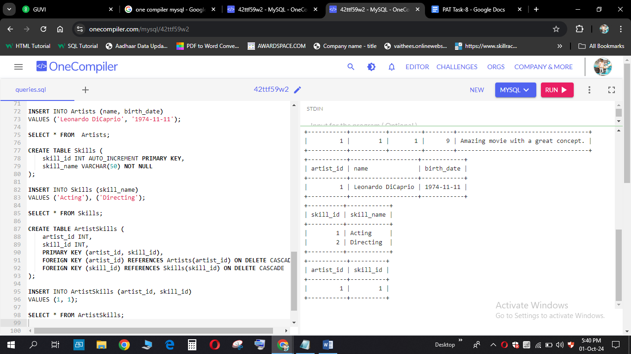

CREATE TABLE Roles (

role_id INT AUTO_INCREMENT PRIMARY KEY,

role_name VARCHAR(50) NOT NULL

);

INSERT INTO Roles (role_name)

VALUES ('Actor'), ('Director');

SELECT * FROM Roles;

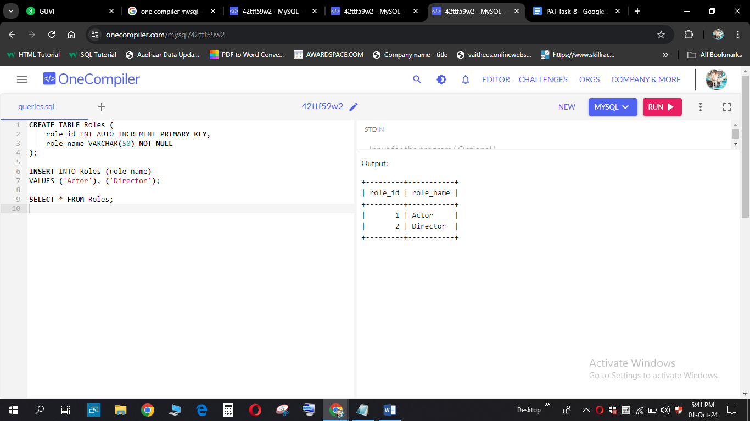

CREATE TABLE ArtistRoles (

movie_id INT,

artist_id INT,

role_id INT,

PRIMARY KEY (movie_id, artist_id, role_id),

FOREIGN KEY (movie_id) REFERENCES Movies(movie_id) ON DELETE CASCADE,

FOREIGN KEY (artist_id) REFERENCES Artists(artist_id) ON DELETE CASCADE,

FOREIGN KEY (role_id) REFERENCES Roles(role_id) ON DELETE CASCADE

);

INSERT INTO ArtistRoles (movie_id, artist_id, role_id)

VALUES (1, 1, 1);

SELECT * FROM ArtistRoles;

